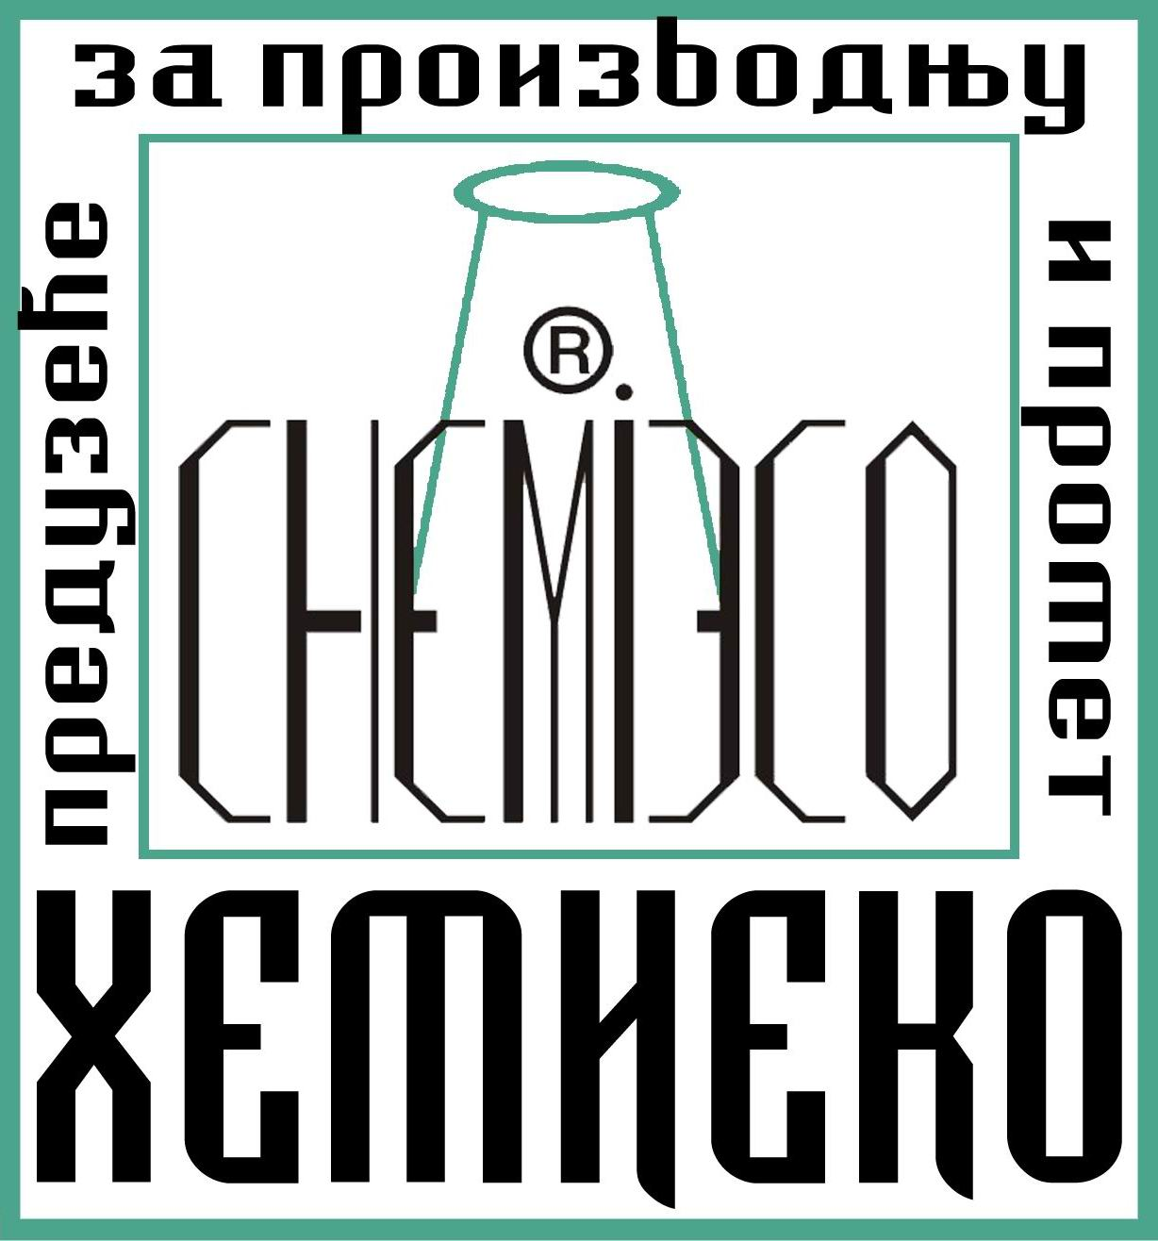

HEMI ECO Belgrade 11030
Development & Production center Blagoja Parovića str. 4
Phone 00381 11 3555724
Fax 00381 11 3555724
Mobile 00381 63 318125
00381 62 355511

www.hemieco.co.rs
_______________________________________________________________________________________

REFERENCE LIST

LIST OF SIGNIFICANT OBJECTS WHO HAS UNDERGONE
REPAIRS – HYDRO INSULATION – RESTORATION – RECONSTRUCTION
CONSOLIDATION – CONSERVATION
USING MESNS AND TECHNOLOGY HEMI ECO

CHURCHES • MONASTERIES • MEMORIALS

Aleksandar Nevski Church - Belgrade · Holy Assumption of our Lord Church - Boleč, Belgrade · Gračanica Monastery - Gračanica, Priština · Sisojevac Monastery - Sisevac, Ćuprija · Visoki Dečani Monastery - Peć · Pavlovac Monastery - Kosmaj · St. Petka’s Monastery - Izvor · Hilandar Monastery - Mount Athos, Greece · Ostrog Monastery, cell Piperska - Bjelopavlići, Danilovgrad · Duga Monastery - Bioča · St. Marco’s Church - Belgrade · St. Nicholas’ Church - Žlijebi · Church of the Holy Trinity - Gornji Milanovac · St. Archangel’s Church - Klinci, Luštica · Velike Gospojine Church - Savine · Church of St. Basil of Ostrog - Kumbor · St. Nicholas’ Church - Lučići · Church of the Holy Trinity - Kuti · St. John’s Church - Kameno · St. George’s Church - Marovići, Luštica · Church of St. Basil of Ostrog - Svrčuge · St. Ilija’s Church - Lastva · St. George’s Church - Mirač · St. Toma’s Church - Trebjesin · St. Šćepan’s Church - Kameno · St. Nicholas’ Church - Luštica · Captain Miša’s Mansion - Belgrade · St. George’s Church - Lazarevići · Church of Holy Shroud of the Theotokos - Kumbor · St. Michael’s Orthodox Cathedral - Belgrade · Holy Father Nicholai Church - Zemun · Church of Mother of God - Zemun · Log Cabin Church - Vranić, Belgrade · Orthodox Cathedral of Christ the Saviour - Banja Luka · St. Sava’s Church - Mrkonjić Grad · Holy Transfiguration of our Lord Church - Savski venac, Belgrade · St. Sava’s Church - Belgrade · King Peter I Memorial, a complex of monuments - Oplenac · Bishop’s Court - Novi Sad · Orthodox Cathedral of the Holy Transfiguration - Trebinje · Ravanica Monastery - Senje, Ćuprija · Church of Translation of Relics of Holy Father Nikolai - Ostružnica, Belgrade · St. George’s Church - Pljevlja · Žiča Monastery, Spiritual Center St. Nikolai of Žiča - Kraljevo · Church of Saint Athanasius the Great - Zemun · Bishop’s Court - Vršac · Church of the Holy Transfiguration of the Lord - Prolom · Church of the Ascension of Christ Monastery Beočin - Beočin ·

THEATRES • MUSEUMS • GALLERIES • INSTITUTIONS • FACULTIES

Faculties of Technical Sciences - Belgrade · National Theatre - Belgrade · Faculty of Law - Belgrade Gallery Josip Bepo Benković - Herceg Novi · Faculty of Economics - Podgorica · Secondary School Center Danilo Kiš - Budva · Publishing Institute - Belgrade · Faculty of Law - Podgorica · Museums and galleries of Podgorica - Podgorica · Theatre Atelje 212 - Belgrade ·

MONUMENTS • MEMORIAL WELLS • FOUNTAINS

Memorial Crypt of Belgrade defenders 1912-1918 - Belgrade · Monument Cross at St. Nicolas’ Square - Belgrade · Monument built for Serbian army in the World War I - Trebinje · Fountain and plateau in front of the palace Beogradjanka - Belgrade · Monument of Rigas Feraios - Belgrade · Sculptures on little Tašmajdan park - Belgrade · Fountain Girl Swimmer - Podgorica · Monument of brothers Nedić - Čokešina, Šabac · Memorial cemetery for the liberators of Belgrade - Belgrade · Monument of Serdar Tomašević - Svrčuge · Monument of Duke Putnik - Belgrade · Monument of Victor - Kalemegdan, Belgrade · Monument built for fighters killed in the World War II - Savina · Monument of Njegos - Belgrade · Well of heroes - Belgrade · Turbe of Sheikh Mustafa - Belgrade · World War II Partisan hospital - Prijepolje · Monument of the Pupins - Idvor · Memorial for the victims of Glavnjača - Belgrade · Archeological site Kolubara B - Lazarevac · Monument of the emperor Nicholas II - Belgrade · Archeological site Petrovaradin - Petrovaradin · Monument to Milojе - Micа Orlovic - Belgrade · Monument to Nikolai Krasnov - Belgrade ·

OBJECTS UNDER STATE PROTECTION

Aleksandar Nevski Church - Belgrade · Holy Assumption of our Lord Church - Boleč, Belgrade ·
Gračanica Monastery - Gračanica, Priština · Sisojevac Monastery - Sisevac, Ćuprija · Visoki Dečani Monastery - Peć · Pavlovac Monastery - Kosmaj · St. Petka’s Monastery - Izvor · Ostrog Monastery, cell Piperska - Bjelopavlići, Danilovgrad · St. Marco’s Church - Belgrade · Sports and Recreation Center Tašmajdan, Tašmajdan rock - Belgrade · Hilandar Monastery - Mount Athos, Greece · Duga Monastery - Bioča · Church of Translation of Relics of Holy Father Nikolai - Ostružnica, Belgrade · St. Michael’s Orthodox Cathedral - Belgrade · Church of Mother of God - Zemun · Log Cabin Church - Vranić, Belgrade · Holy Father Nicholai Church - Zemun · St. Sava’s Church - Belgrade · Holy Transfiguration of our Lord Church - Savski venac, Belgrade · Orthodox Cathedral of Christ the Saviour - Banja Luka · St. Sava’s Church - Mrkonjić Grad · Turbe of Sheikh Mustafa - Belgrade Orthodox Cathedral of the Holy Transfiguration - Trebinje · King Peter I Memorial, a complex of monuments - Oplenac · Bishop’s Court - Novi Sad · Captain Miša’s Mansion - Belgrade · Monument of Rigas Feraios - Belgrade · Church of the Holy Trinity - Gornji Milanovac · Žiča Monastery, Spiritual Center St. Nikolai of Žiča - Kraljevo · Monument of Victor - Kalemegdan, Belgrade · Memorial Crypt of Belgrade defenders 1912-1918 - Belgrade · Monument Cross at St. Nicolas’ Square - Belgrade · Memorial cemetery for the liberators of Belgrade - Belgrade · Monument built for Serbian army in the World War I - Trebinje · National Theatre - Belgrade · Monument of Duke Putnik - Belgrade · Monument of Njegos - Belgrade · Monument of brothers Nedić - Čokešina, Šabac · Faculties of Technical Sciences - Belgrade · Faculty of Law - Podgorica · Gallery Josip Bepo Benković - Herceg Novi · Faculty of Economics - Podgorica · Building of the Spanish Center Cervantes - Belgrade · Faculty of Law - Belgrade · Building of the National Assembly - Belgrade Publishing Institute - Belgrade · Information Center - Herceg Novi · Villa Topliš - Miločer Museums and galleries of Podgorica - Podgorica · Restaurant ? in King Peter I street 8 - Belgrade · Building of the Ministry of Finance - Belgrade · Object in Djura Djaković street 5 - Belgrade · Object in Nemanjina street 9 - Belgrade · Object in Princess Zorka street 7 - Belgrade Object in Cvijićeva street 37 - Belgrade · Ravanica Monastery - Senje, Ćuprija · Object in Glavna street 33 - Zemun · Memorial for the victims of Glavnjača - Belgrade · Bishop’s Court - Vršac · World War II Partisan hospital - Prijepolje · Object in gospodar Jevremova street 21 - Belgrade · Theatre Atelje 212 - Belgrade · Object in gospodar Jevremova street 4 - Belgrade · Church of the Ascension of Christ Monastery Beočin - Beočin ·

OTHER OBJECTS

Building of the Spanish Center Cervantes - Belgrade · Villa Topliš - Miločer · Building of the First Serbian Singing Society - Belgrade · Building of the National Assembly - Belgrade · Building of the Ministry of Finance - Belgrade · FMP - Factory of metal products - Belgrade · Building of the Government of Montenegro - Podgorica · Production Unit Kluz - Grocka, Belgrade · Administration Building of the Government of Montenegro - Podgorica · Object in Strumička street 12 - Belgrade ·
OTHER OBJECTS

Stadium of the football club Železnik - Belgrade · Object in Radoje Domanović street 24 - Belgrade
Building of the Regional Flight Control Center Surčin - Surčin · Clock Tower - Herceg Novi · Transformer station Bežanija 110/10kV - Belgrade · Object in Draže Pavlovića street 22 - Belgrade ·
Business Center Zetatrans - Nikšić · Stadium of the football club Budućnost - Podgorica · Restaurant ? in King Peter I street 8 - Belgrade · General Hospital Danilo I - Cetinje · Building of Municipality of Nikšić - Nikšić · Hotel Centar (former rehabilitation center) - Igalo · Hotel chain of Hotel-Tourist Enterprise Boka - Igalo · Information Center - Herceg Novi · Restaurant Mc Donald’s in Mihajlo Pupin Boulevard 85a - Belgrade · Object in Cvijićeva street 37 - Belgrade · Object Media House in Bulevar Oslobodjenja 107 - Belgrade · Object in Glavna street 33 - Zemun · Youth Cyclist Club of Belgrade in Despot Stefan Boulevard 204 - Belgrade · Object in Hopovska street 74 - Borča, Belgrade · Object in Nemanjina street 9 - Belgrade · Object in Miloje Djak street 5 - Belgrade · Object in Djura Djaković street 5 - Belgrade · Object in Birčaninova street 27 - Belgrade · Object in Venizelosova street 60 - Belgrade · Object in Bulevar Mira street 69 - Belgrade · Object in Tolstoy street 16a - Belgrade · Object in Baja Pivljanin street 17 - Belgrade · Object in Avgust Cesarac street 27v - Belgrade · Object in Požeška street 85 - Belgrade · Object in Vidska street 29 - Belgrade · Object in Sculptor Djoka Jovanović street 35 - Belgrade · Object in Sculptor Djoka Jovanović street 2b - Belgrade · Object in Sculptor Djoka Jovanović street 2v - Belgrade · Building of the Bank of Nikšić - Nikšić · Object in Princess Zorka street 7 - Belgrade · Sports Center Vizura - Zemun · The general hospital Bel Medic in Koste Jovanovića street 87 - Belgrade · Villa San - Kopaonik · Avala Tower - Avala, Belgrade · Object in Gvozdićeva street 16 - Belgrade · Object in Despota Stefana Street 5 - Vrbas · Commercial building Sumadija granite - Arandjelovac · Object in Stari vinogradi street 50e - Belgrade · Object in Miloje Zakić street 92 - Belgrade · Restaurant Fish&Bar - Belgrade
Object in Gospodar Jevremova street 4 - Belgrade · Object in Kostolačka street 12-14 - Belgrade · Hotel Hilton - Belgrade · Object in heroja Milana Tepića street 12 - Belgrade · Object in Gospodar Jevremova street 21 - Belgrade · Shopping center Delta City - Belgrade · Hall Park - Herceg Novi ·
Object in Kneza Milosa street 25 - Belgrade · Object in General Anri street 3 - Belgrade ·Object in Kosovska street 5 - Belgrade ·

Belgrade, 2019

